**MethodsCore**

**Path Template Documentation**

**09/05/2012**

Pretty much all Methods Core software will need paths to be specified, and usually lots of them. Luckily, we have an efficient way to set up paths that we call the Path Template method. It takes a moment to get used to, but it should save lots of time and hassles.

The basic idea is that paths are specified as a ‘Template’ that contains both hard-coded text as well as variables that get filled in by the script later. The names of the variables are placed within brackets. To see this idea in action, let’s look at some examples.

*Example#1*

I am going to set up the MasterTemplate for my MasterData file. My MasterData file lives in /net/data4/MAS/Scripts/ and is called ‘MSIT_Master_methodscore.csv’. Given this information, my MasterTemplate could be specified like this:

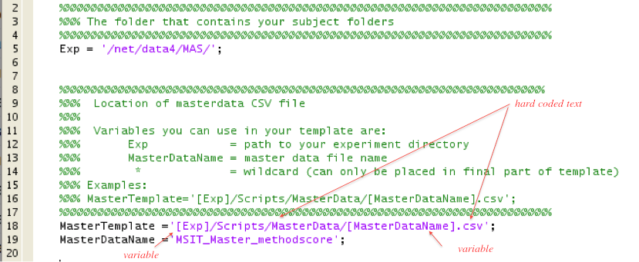

The script will substitute in the value of the variables when it uses the MasterTemplate.

Pretty much every template will have the Exp variable in it. This is your experiment directory and gets set up at the top of the script you are working with. So feel free to use it in your Templates. If you are in doubt about which variables you can use, then look at the Help right above where the Template gets specified. It will always list the main variables you can use.

*Example#2*

Now let’s look at a different example. This time I am going to specify the ImageTemplate for my functional images.

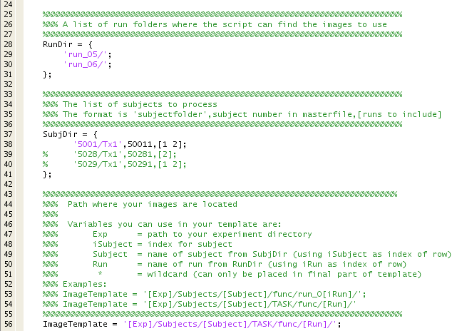

Once again, the script will substitute in the value of the variables when it uses the ImageTemplate. And once again, you can look above where the Template gets specified to get a list of variables you can use in the Template.

Let’s say that my functional images are in a sub-folder within ‘func’ called ‘MSIT’. My ImageTemplate would then look like this:



*Wildcards*

ImageTemplates can use wildcards. Here is an example:



This will find the file that begins with ‘mcflirt’ and ends in ‘.dat’ within the specified folder. This is useful when the needed file has a common stem in its name, but its name otherwise differs across subjects and/or runs. For example, the full name of the above file is mcflirt_realign_a_run_5 in the run_05 folder and mcflirt_realign_a_run_6 in the run_06 folder. Note: if there is more than file in a single folder that fits the wildcard, then you will get an error.